|  |  |  |  |  |
| --- | --- | --- | --- | --- |
| **Product** | **Order** | **Time** | **Customer** | **Currency** |
| Name | SalesTerritoryRegion  [SalesTerritory] | Day | Title  [Person] | Name  [Currency] |
| Color | OrderDate  [SalesOrderHeader] | Month | FirstName  [Person] |  |
| StandardCost | DueDate  [SalesOrderHeader] | Year | MiddleName  [Person] |  |
| ListPrice | ShipDate  [SalesOrderHeader] | Date | LastName  [Person] |  |
| Size | DiscountPct  [SpecialOffer] |  | Gender  [vPersonDemographics] |  |
| SizeUnitMeasure | StartDate  [SpecialOffer] |  | BirthDate  [vPersonDemographics] |  |
| Weight | EndDate  [SpecialOffer] |  | MaritalStatus  [vPersonDemographics] |  |
| WeightUnitMeasure | MinQty  [SpecialOffer] |  | EmailAddress  [EmailAddress] |  |
| ProductLine | MaxQty  [SpecialOffer] |  | YearlyIncome  [vPersonDemographics] |  |
| Class |  |  | TotalChildren  [vPersonDemographics] |  |
| Style |  |  | NumberChildrenAtHome  [vPersonDemographics] |  |
| Category |  |  | Education  [vPersonDemographics] |  |
| Subcategory |  |  | Occupation  [vPersonDemographics] |  |
| Model |  |  | HomeOwnerFlag  [vPersonDemographics] |  |
|  |  |  | NumberCarsOwned  [vPersonDemographics] |  |
|  |  |  | AddressLine1  [Address] |  |
|  |  |  | AddressLine2  [Address] |  |
|  |  |  | City  [Address] |  |
|  |  |  | PostalCode  [Address] |  |
|  |  |  | State  [StateProvince] |  |
|  |  |  | Country  [CountryRegion] |  |
|  |  |  | PhoneNumber  [PersonPhone] |  |
| Measures | Quantity, Sale Turnover | | | |

Lab4 - IS1419 - Đỗ Tuấn Long – HE141276

**Product**

- Hierarchies: Category – Subcategory – Name, Model – Name, Category – Subcategory, Name – ListPrice, WeightUnitMeasure – Name, SizeUnitMeasure - Name

- Categories: Color, StandardCost, Size, Weight, Class, Style

**Order**

- Hierarchies:

- Categories: OderDate, DueDate, ShipDate, SalesTerritoryRegion, DiscountPct, StartDate, EndDate, MinQty, MaxQty

**Time**

- Hierarchies: Year – Month - Day

- Categories: Date

**Customer**

- Hierarchies: Country – State - City

- Categories: Title, FirstName, MiddleName, LastName, Gender, BirthDate, MaritalStatus, EmailAddress, YearlyIncom, TotalChildren, NumberChildrenAtHome , Education, Occupation, HomeOwnerFlag, NumberCarsOwned, AddressLine1, AddressLine2, PostalCode, PhoneNumber

**Currency**

- Hierarchies:

- Categories: Name

Level of details: DW stores online sales by price range, cost range, weight range, and currency for each product with individual customers in the region where the sale takes place.

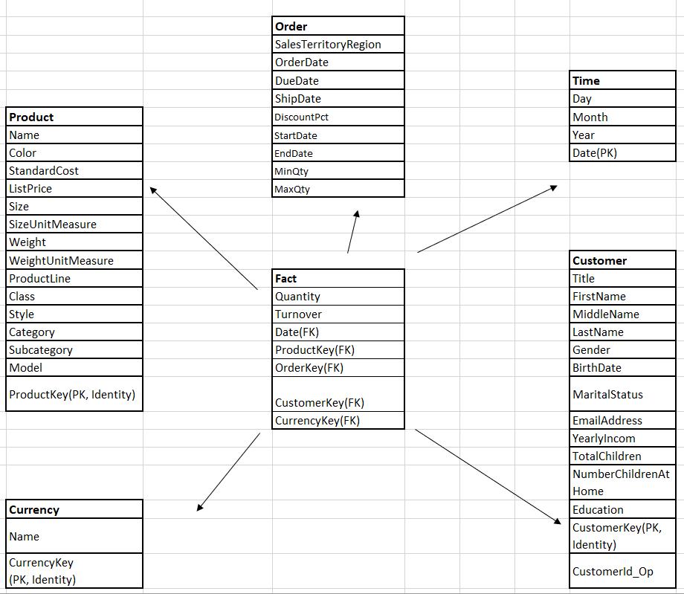

PK Fact = (ProductKey, CustomerKey, Orderkey)

1 line of fact stores revenue by the number of each product sold to each individual customer in each region's currency